GrantTrak
Mississippi
Department
Of Employment
Security

Subrecipient User Manual

Revision 1, MM/DD/YYYY

GrantTrak Manual
Basics 4
Logging in to GrantTrak 5
Home Page 7
Logging Out 8
GrantTrak Navigation 9
Top Navigation 10
Search Results Screen 11
View, Search, Creation, and Edit Screens 12
Global Features and Functions 13
Attachments 14
Calendars and Dates 15
Selection Dropdown 16
Notices of Fund Availability 17
Searching for a Notice of Fund Availability 18
Viewing a Notice of Fund Availability 19
Cash Request 21
Creating a Cash Request 22
Searching for a Cash Request 24
Viewing a Cash Request 25
Editing a Cash Request 27
Deleting a Cash Request 28
Submitting a Cash Request to Workflow 29
Signing a Cash Request 30
Rejecting Status Changes 31
Transfer 32
Creating a Transfer 33
Searching for a Transfer 35
Viewing a Transfer 36
Editing a Transfer 38
Deleting a Transfer 39
Submitting a Transfer to Workflow 40
Signing a Transfer 41
Rejecting Status Changes 42
Worksheet 43
Creating a Worksheet 44
Searching for a Worksheet 46
Viewing a Worksheet 47
Editing a Worksheet 49
Deleting a Worksheet 51
Submitting a Worksheet to Workflow 52
Signing a Worksheet 53
Rejecting Status Changes 54

Basics

Logging in to GrantTrak
Type your username and password in the login box and click Log In.
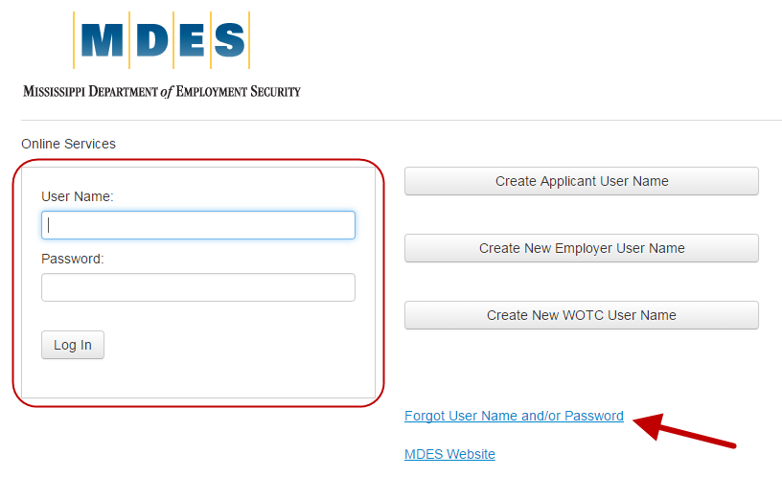
If you do not have a username and password, you must ask your manager to register an account for you. You will not be able to register for a staff login yourself.
If you have forgotten your username or password, click the Forgot Username and/or Password link.
Dashboard
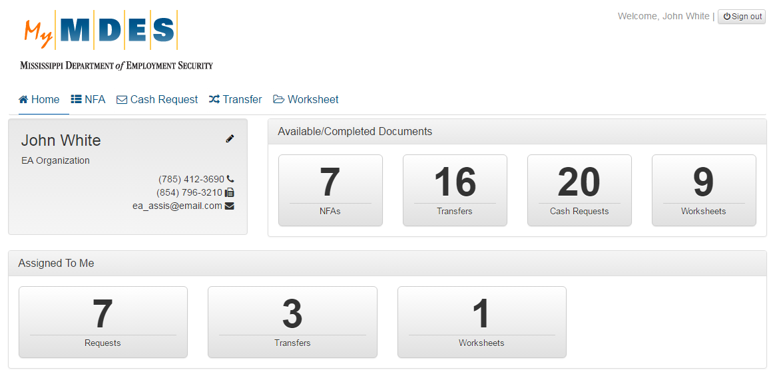
See the next section for details on the Dashboard.

Home Page
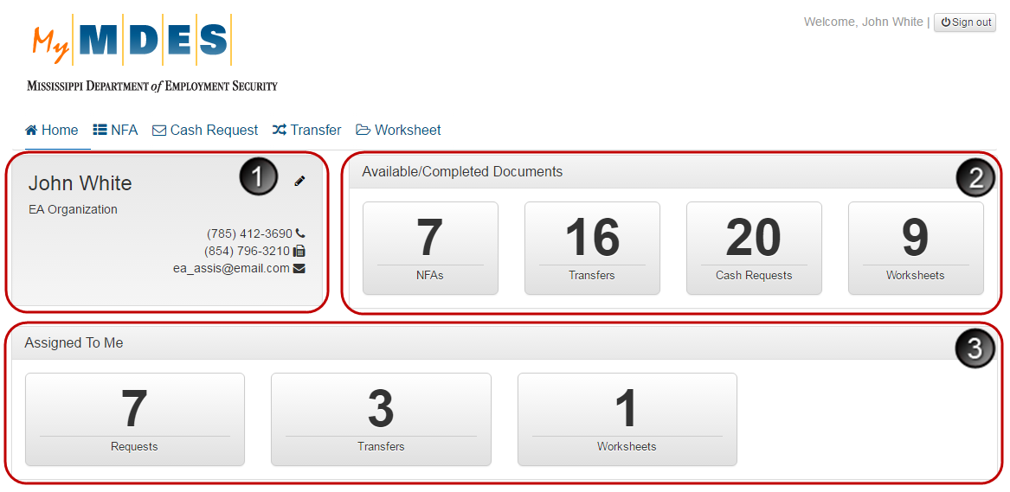
The Home page with the Dashboard is the first screen users see after logging in. The Dashboard allows the users to view the following:
- Name, organization and contact information of the currently logged-in user.
- Available/Completed Documents – The total number of NFAs, Transfers, Cash Requests, and Worksheets available to the logged-in user.
- Assigned To Me – The number of items assigned to the logged-in user.
Clicking any number on the Dashboard will navigate you to the corresponding search results page, filtered accordingly.
NOTE: The number of available sections that are displayed on the Home page depends on your role in the system.

Logging Out
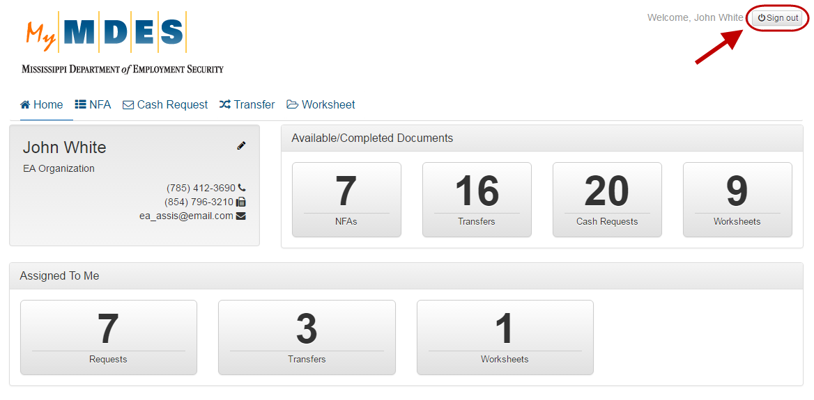
The Sign out button is located in the top-right corner of every screen.

GrantTrak Navigation

Top Navigation
Top Navigation Menu
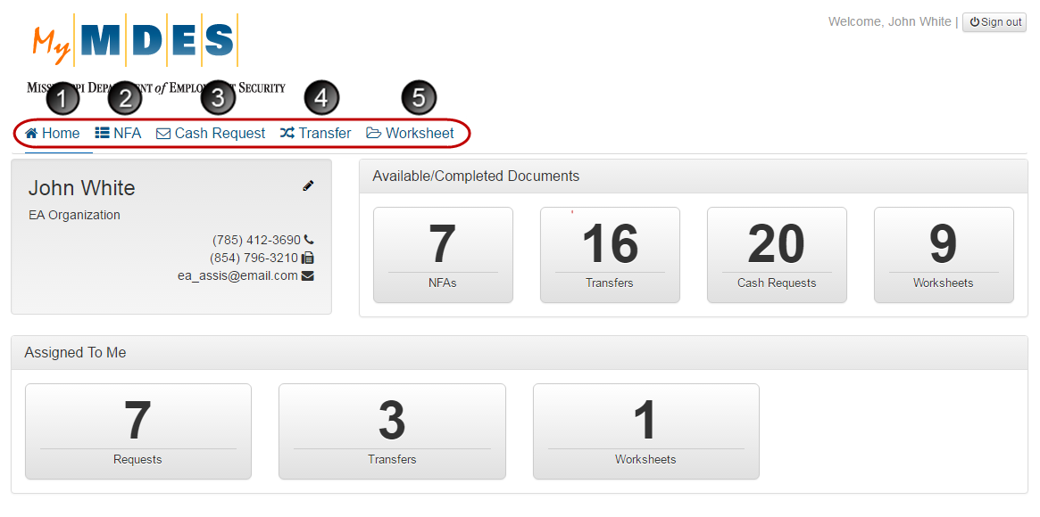
All GrantTrak features and functions can be reached from the top menus at any time during a session. The top menus are (1) Home, (2) NFA, (3) Cash Request, (4) Transfer, (5) Worksheet. Clicking each menu link will display the appropriate screen related to this menu.
NOTE: The number of available menus depends on your role in the system.

Search Results Screen
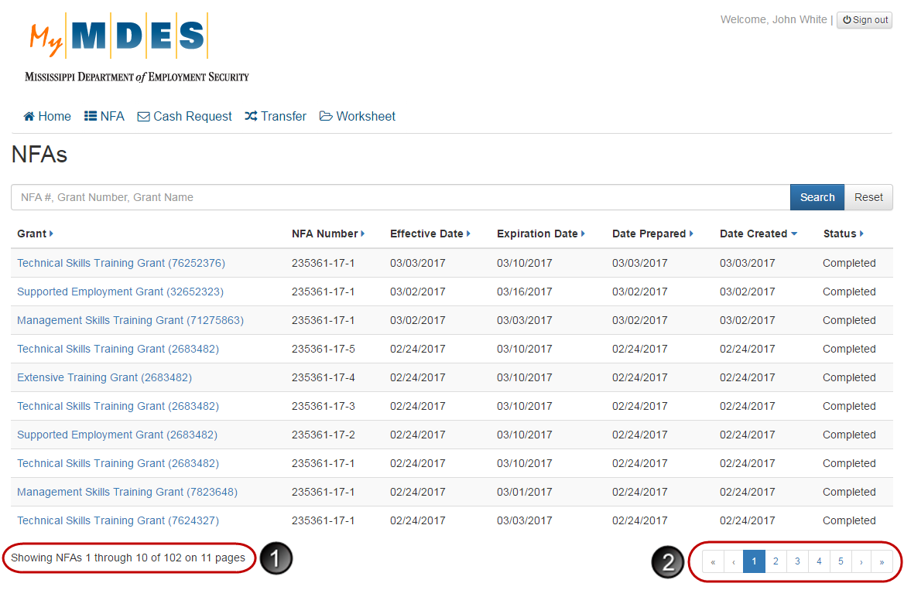
Clicking any menu link on the top navigation bar, except for Home, will display the appropriate search results screen.
- The line to the bottom left of the screen indicates the total number of search result items and the number of items displayed on the page.
- The line to the bottom right of the screen contains the following pagination options:
- << (First): Opens the first screen of search results.
- < (Prev): Navigates to the previous screen of search results.
- Numbers (1, 2, 3, etc.): Navigates to the corresponding screen of search results.
- > (Next): Navigates to the next screen of search results.
- >> (Last): Opens the last screen of search results.

View, Search, Creation, and Edit Screens
Buttons Overview
Return to Search navigates to a Search Results screen.
Search displays search records according to the entered criteria.
Reset returns the search results screen to a default state.
Cancel returns to the previous screen. If Cancel is clicked on a creation or edit screen, any changes made to the form will be discarded.
Delete removes the currently selected record.
Create appears on search results and view screens and allows users to create records.
Save appears on edit and creation screens and allows users to save changes or add a record.
Print allows users to print the currently displayed record.
Submit allows users to change a status of a record.
View History displays a history of status changes for a record.
Recalculate Totals adjusts the read-only values on screens according to the entered amount.
Search Screen Buttons

View Screen Buttons

Creation and Edit Screen Buttons

Global Features and
Functions

Attachments
Documents can be attached on several view screens in the system. To attach a document:
Step 1: Click the Folder icon and select the required file from your local directory.
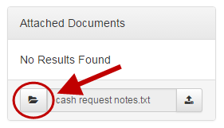
Step 2: Once selected, click the Upload icon.
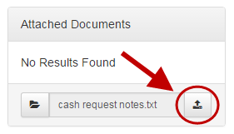
The attached file will appear in the Attached Documents section. To download an attachment, click the attachment link.
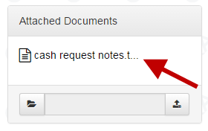
NOTES:
- Only the following file types can be attached on view screens: .csv, .pdf, .txt, .doc, .docx, .xls, .xlsx. The size of the attached file cannot be greater than 10 MB.
- Subrecipient users can only delete attachments that they added.

Calendars and Dates
Calendar Picker Menu
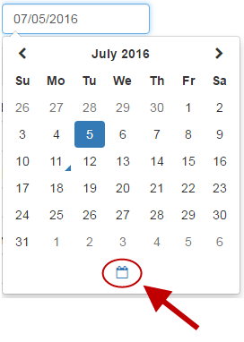
Clicking a date input field will open a calendar picker where you can choose a month, year, and day. If it is required to enter the current date, click the calendar icon to complete the field with the current date.
Dates can also be entered as the following (m =Month, d= Day, y=Year):
- 1st [etc.]
- 1st Jan [etc.]
- 1st Jan 2006 [etc.] Jan 1st [etc.]
- Jan 1st 2006 [etc.]
- mm/dd/yyyy
- mm-dd-yyyy
- mmddyyyy
- mmddyy
- mm.dd.yyyy
- yyyy-mm-dd
- mm/yyyy
- mm-yyyy
- mm.yyy
- yyyy/mm
- yyyy-mm
- yyyy.mm

Selection Dropdown
Dropdown List
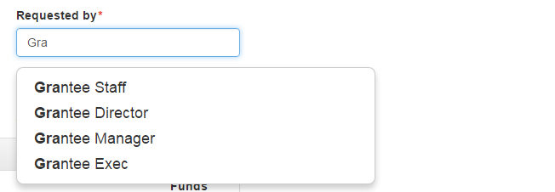
To complete some of the fields in the system, it is required to select an option from a dropdown list. To display a dropdown list of available matches, type the first 3 characters in the field. If there are no available options for the entered criteria, the ‘No Matches Found.’ message will display.
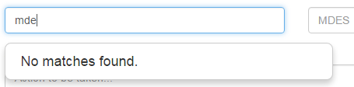

Notices of Fund Availability

Searching for a Notice of Fund Availability
Grantee Staff members, Grantee Managers, Grantee Directors, Grantee Executives, and Board Chairmen can search for NFAs that have the ‘Completed’ status.
Step 1: Click NFA.
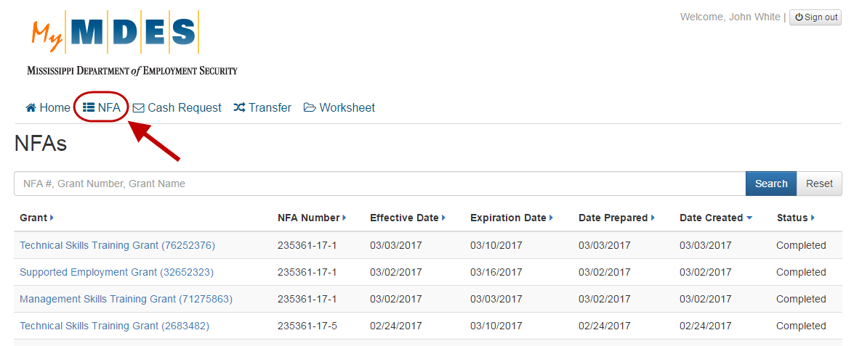
Step 2: Type an NFA number, grant number or grant name and click Search.
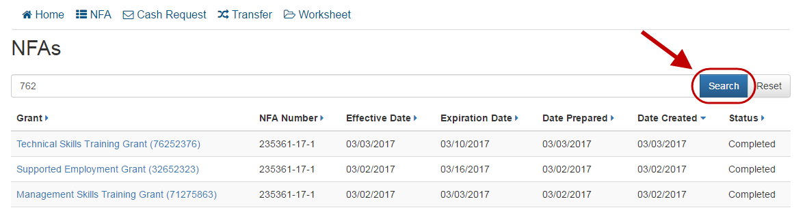
Search Results Screen
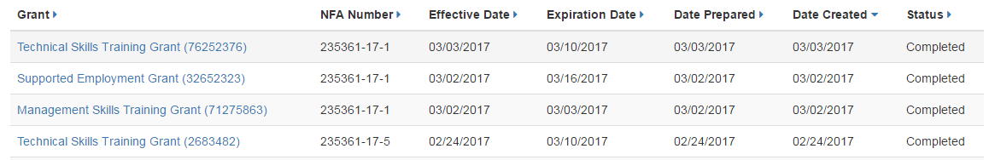
NOTE: By default, records in the grid are sorted by the Date Created column, but can be sorted by other column criteria.
Clicking any grant name in the search results will open the corresponding Notice of Fund Availability View screen. For more details, refer to the Viewing a Notice of Fund Availability section.

Viewing a Notice of Fund Availability
Grantee Staff members, Grantee Managers, Grantee Directors, Grantee Executives, and Board Chairmen can view NFAs that have the ‘Completed’ status.
To open a Notice of Fund Availability View screen with associated details, click the grant name in the search results list. For details on how to search for an NFA, refer to the Searching for a Notice of Fund Availability section.
Notice of Fund Availability View Screen
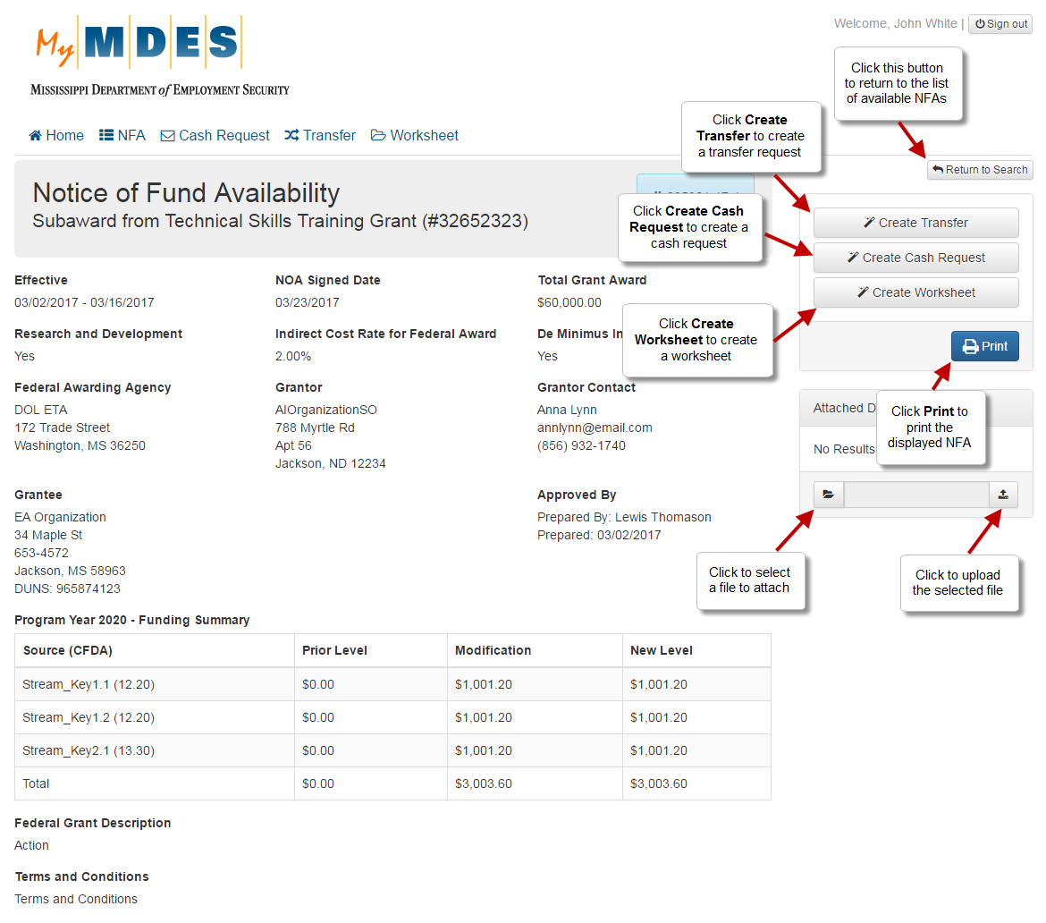
The NFA View screen provides access to the information about the NFA, related actions and documents in the GrantTrak system.
NOTE: The number of available actions on the NFA View screen depends on your role in the system.

Attach Documents to an NFA

On an NFA View screen, you can attach documents to the selected NFA. To attach a document:
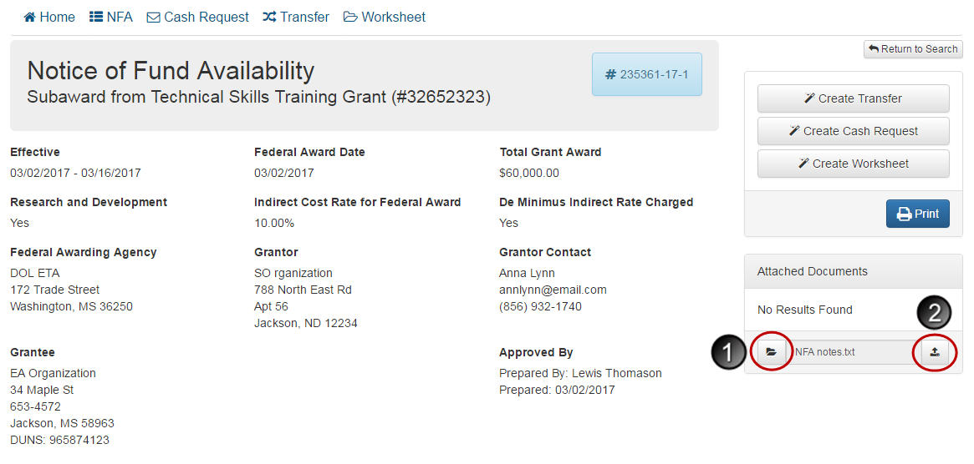
- Click the folder icon and select the required document from your local directory.
- Click the upload icon to attach the selected file.

Cash Request

Creating a Cash Request
Grantee Staff members, Grantee Managers, Grantee Directors and Grantee Executives can create cash requests.
Cash requests are created from the Notice of Fund Availability View screen for NFAs associated with your current organization. For details on other actions available for an NFA, refer to the Viewing a Notice of Fund Availability section.
Step 1: Click NFA and select the required NFA from the list, from which you want to create a cash request.
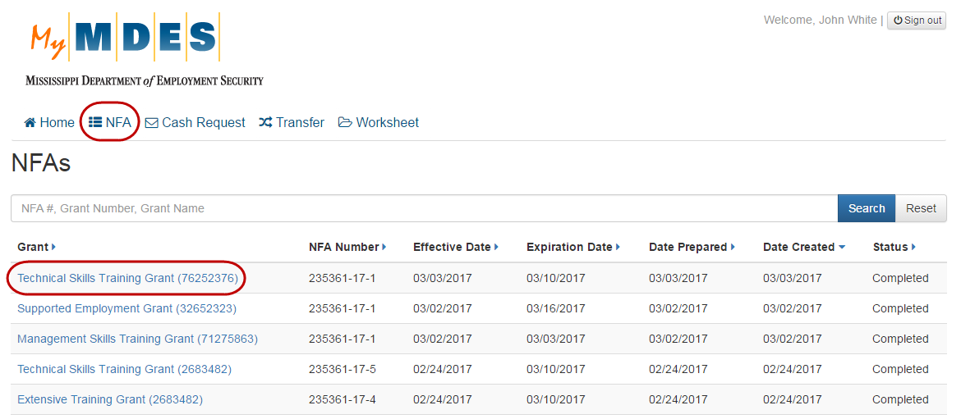
Step 2: On the NFA View screen, click Create Cash Request.
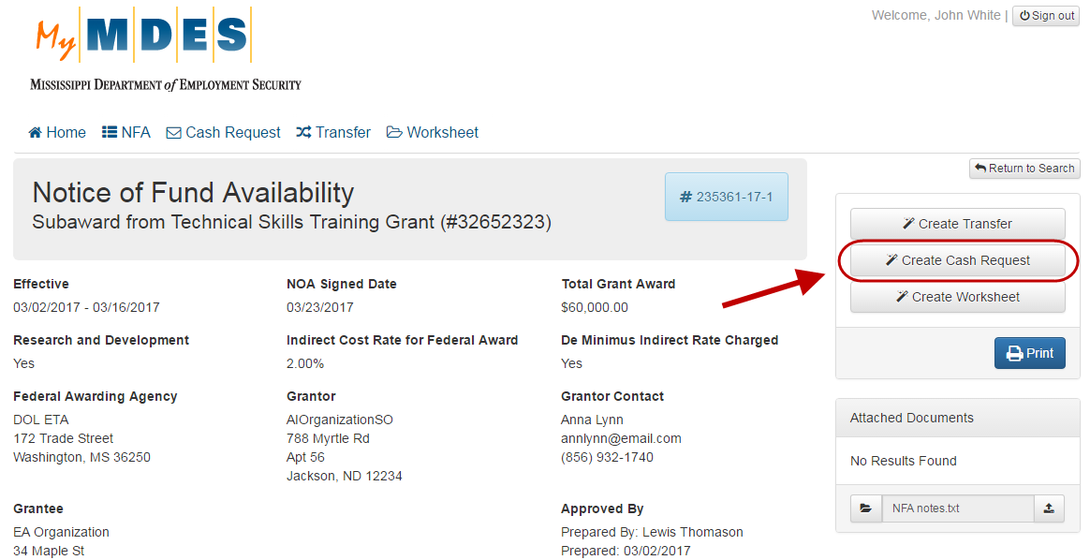
Step 3: Complete the fields on the New Cash Request screen and click Save.
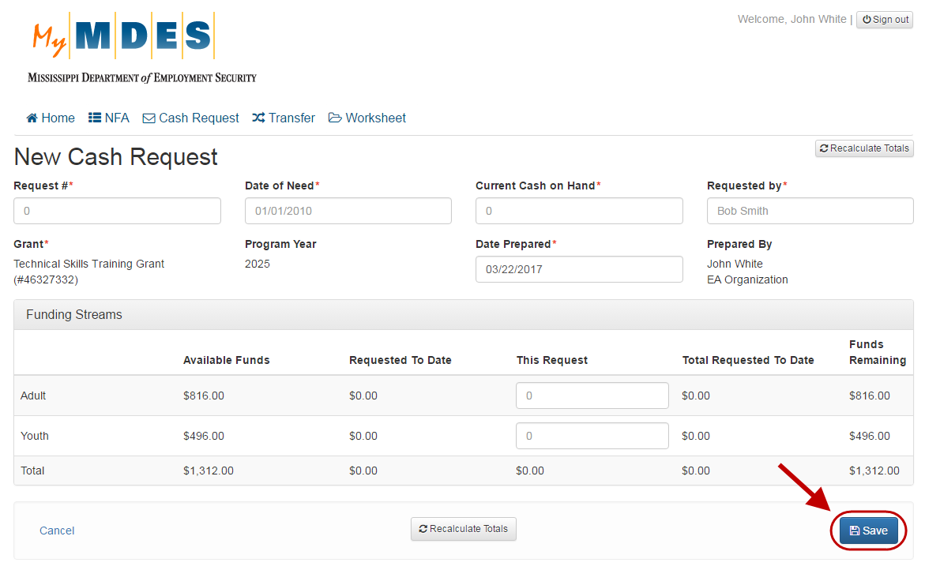
NOTE: Use the Recalculate Totals button to recalculate the remaining amount according to the entered request value.

Searching for a Cash Request
Grantee Staff members, Grantee Managers, Grantee Directors, and Grantee Executives can search for cash requests.
Step 1: Click Cash Request.
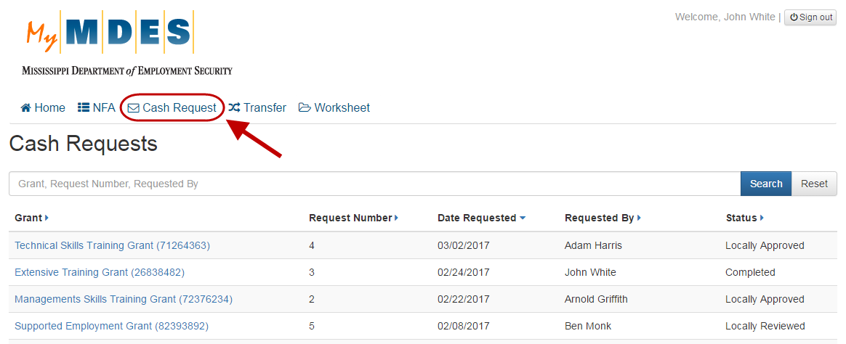
Step 2: A Requests screen will appear. Type a grant number/name, a request number or a requester name and click Search.
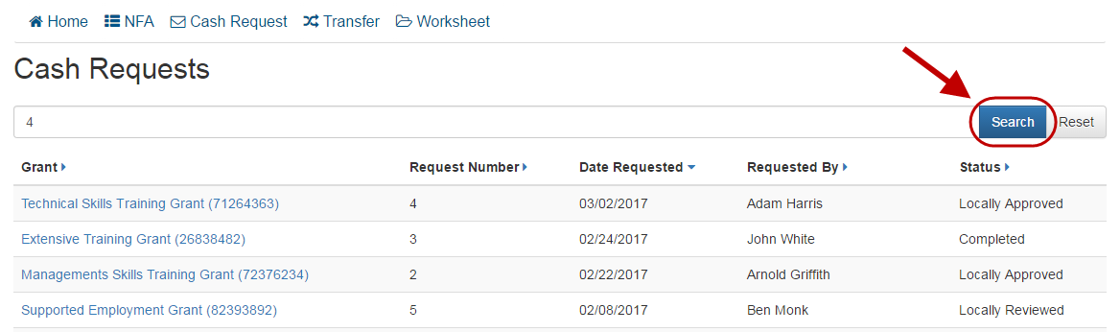
Search Results Screen
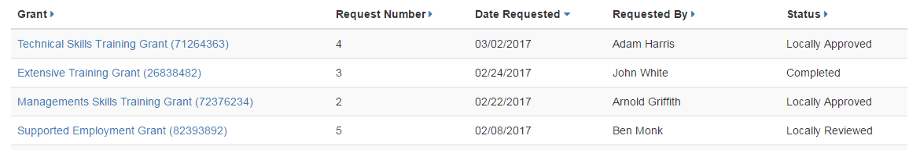
NOTE: By default, records in the grid are sorted by the Date Requested column, but can be sorted by other column criteria.
Clicking any grant name in the search results will open the corresponding Cash Request View screen. For more details, refer to the Viewing a Cash Request section.

Viewing a Cash Request
Grantee Staff members, Grantee Managers, Grantee Directors, and Grantee Executives can view cash requests in any status. Board Chairmen can only view NFAs that have the ‘Completed’ status.
To open a Cash Request View screen with associated details, click the grant name in the search results list. For details on how to search for a cash request, refer to the Searching for a Cash Request section.
Cash Request View Screen (for the following user roles: Grantee Staff members, Managers, Directors and Executives)
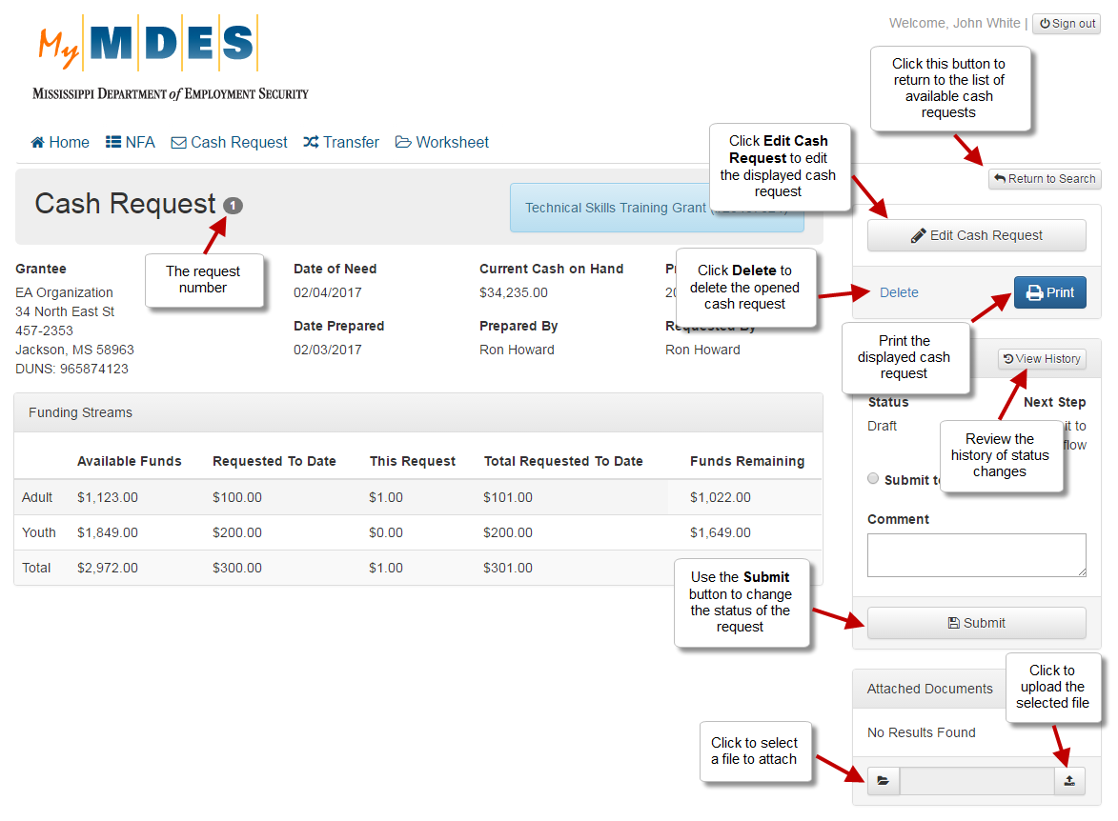
NOTE: The number of available actions on the screen depends on the status of the cash request.
Attach Documents to a Cash Request

On a Cash Request View screen, you can attach documents to the selected cash request. To attach a document:
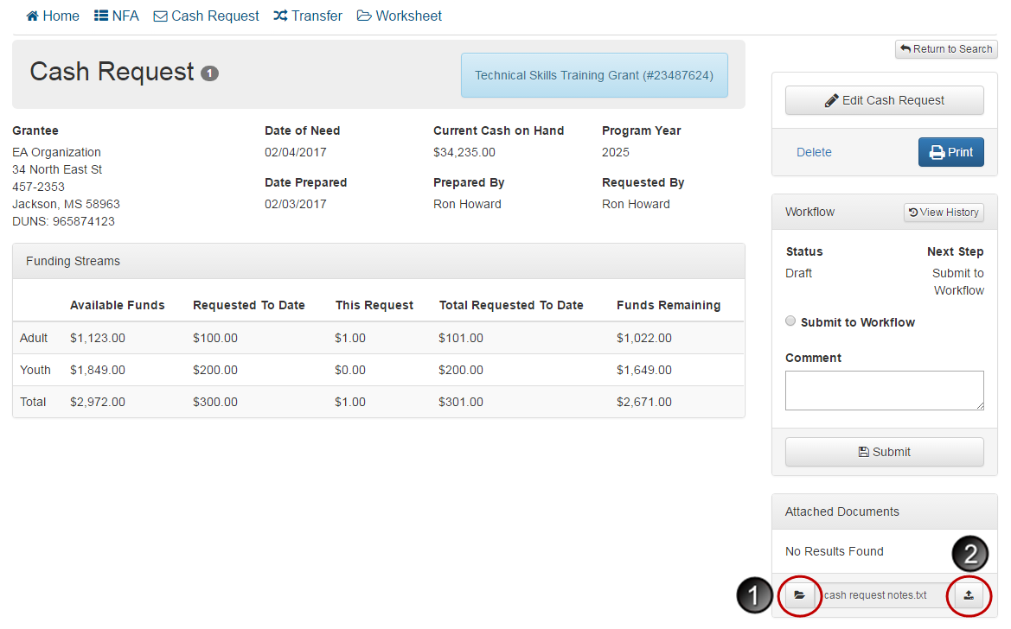
- Click the folder icon and select the required document from your local directory.
- Click the upload icon to attach the selected file.

Editing a Cash Request
Grantee Staff members, Grantee Managers, Grantee Directors and Grantee Executives can edit cash requests that have a status of ‘Draft’.
Information related to a cash request can be modified from the associated Cash Request View screen. For details on other functions available for cash requests, refer to the Viewing a Cash Request section.
Step 1: Click the Edit Cash Request button on the Cash Request View screen.
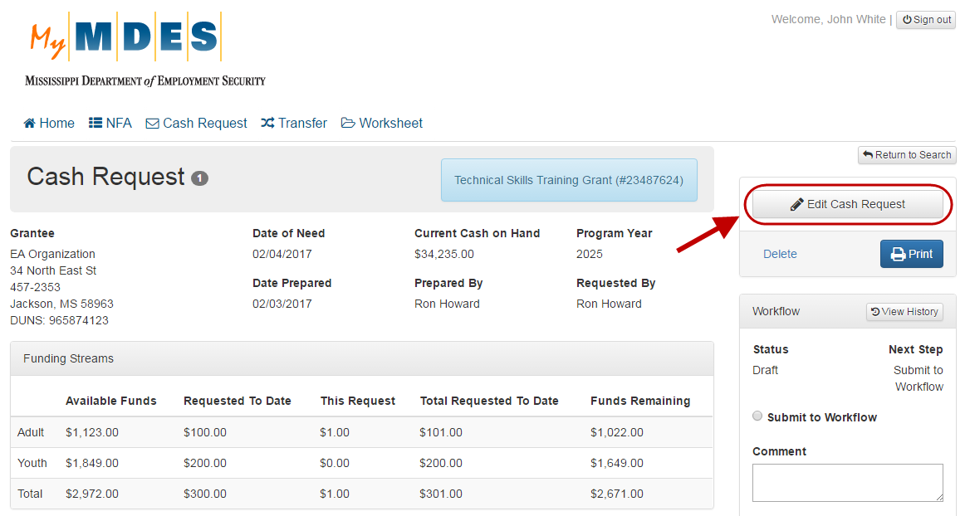
Step 2: Edit information as necessary and click Save.
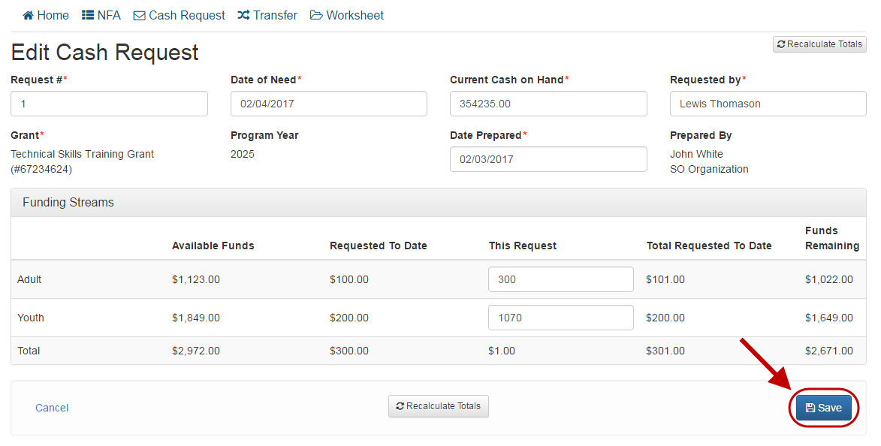

Deleting a Cash Request
Grantee Staff members, Grantee Managers, Grantee Directors and Grantee Executives can delete cash requests that have a status of ‘Draft’.
Information related to a cash request can be deleted from the associated Cash Request View screen. For details on other functions available for cash requests, refer to the Viewing a Cash Request section.
Step 1: Click the Delete link on the Cash Request View screen.
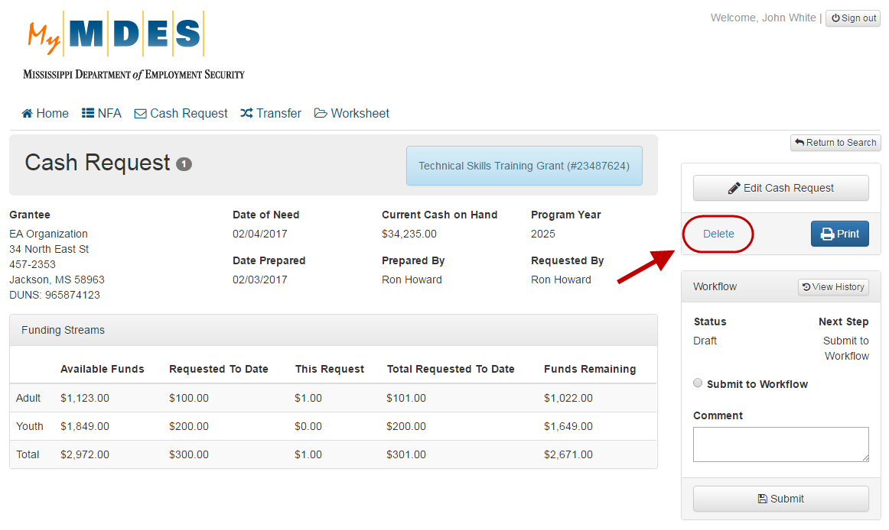
Step 2: Click Yes to confirm the removal.
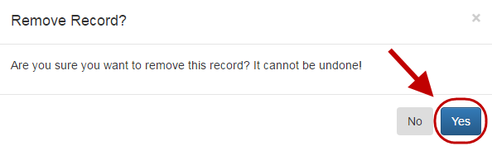

Submitting a Cash Request to Workflow
Grantee Staff members, Grantee Managers, Grantee Directors and Grantee Executives can submit cash requests to Workflow.
In order to initiate the process of approving a cash request, it must be submitted to Workflow from the associated Cash Request View screen. For details on other actions available for cash requests, refer to the Viewing a Cash Request section.
Submit a Cash Request to Workflow
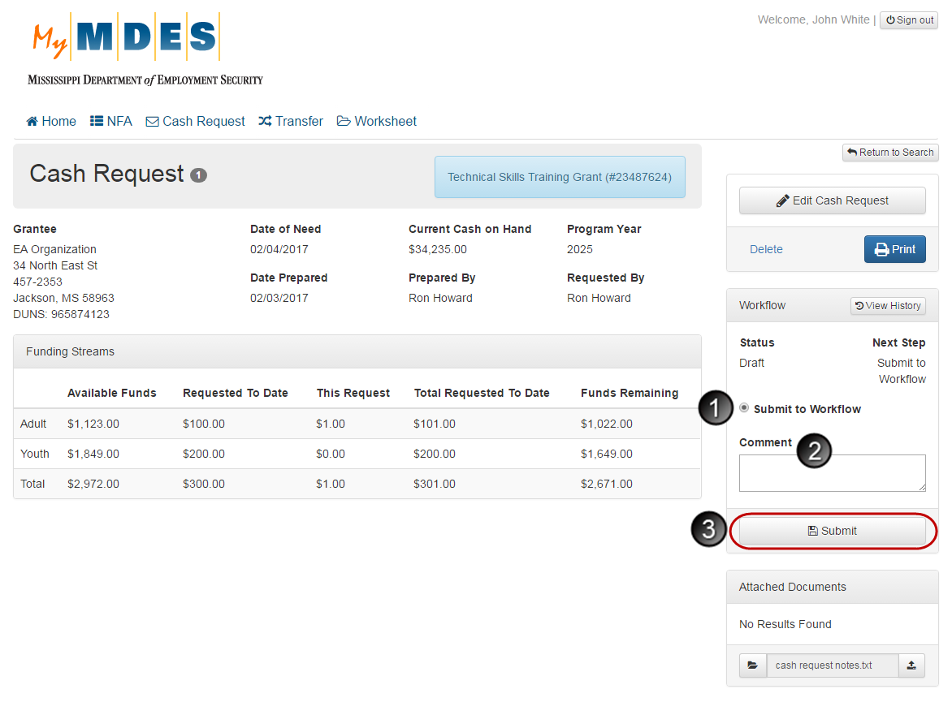
To submit a cash request to Workflow:
- Select Submit to Workflow in the Workflow section.
- Enter a comment in the Comment field.
- Click the Submit button.
NOTE: Clicking Submit will change the status from ‘Draft to ‘Submitted to Workflow’.

Signing a Cash Request
Grantee Managers, Grantee Directors and Grantee Executives can locally sign cash requests that have a status of ‘Submitted to Workflow’.
Cash requests can be signed from the associated Cash Request View screen. For details on other actions available for cash requests, refer to the Viewing a Cash Request section.
Sign a Cash Request
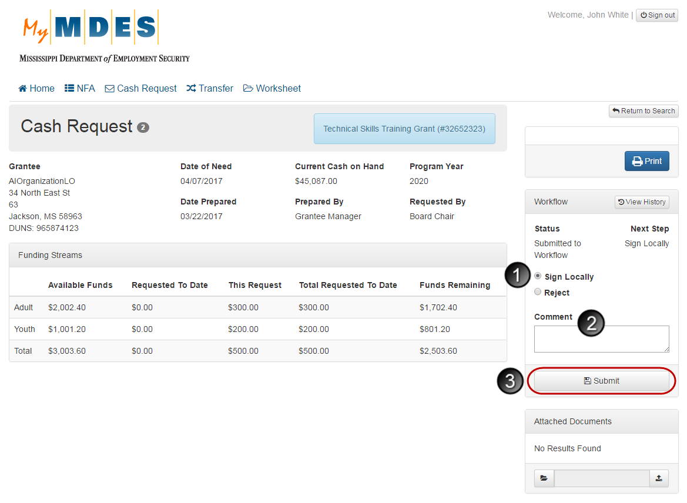
To sign a cash request:
- Select Sign Locally in the Workflow section.
- Enter a comment in the Comment field.
- Click the Submit button.
NOTE: Clicking Submit will change the status to ‘Locally Signed’.
Once the cash request has been locally signed, further status changes (state review and approval) are available only to State Office users.

Rejecting Status Changes
If necessary, a status change, which has been submitted, can be rejected.
NOTE: After a cash request has been locally signed, the status cannot be rejected.
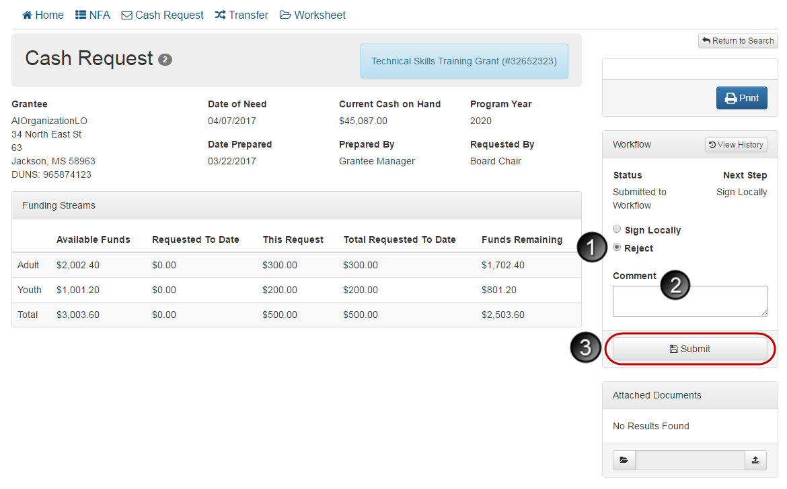
To reject a status change:
- Select Reject in the Workflow section.
- Enter a comment in the Comment field.
- Click the Submit button.
NOTE: Clicking Submit will change the status to ‘Draft’.

Transfer

Creating a Transfer
Grantee Staff members, Grantee Managers, Grantee Directors and Grantee Executives can create transfers.
Cash requests are created from the Notice of Fund Availability View screen for NFAs associated with your current organization. For details on other actions available for an NFA, refer to the Viewing a Notice of Fund Availability section.
Step 1: Click NFA and select the required NFA from the list, from which you want to create a transfer.
Step 2: On the NFA View screen, click Create Transfer.

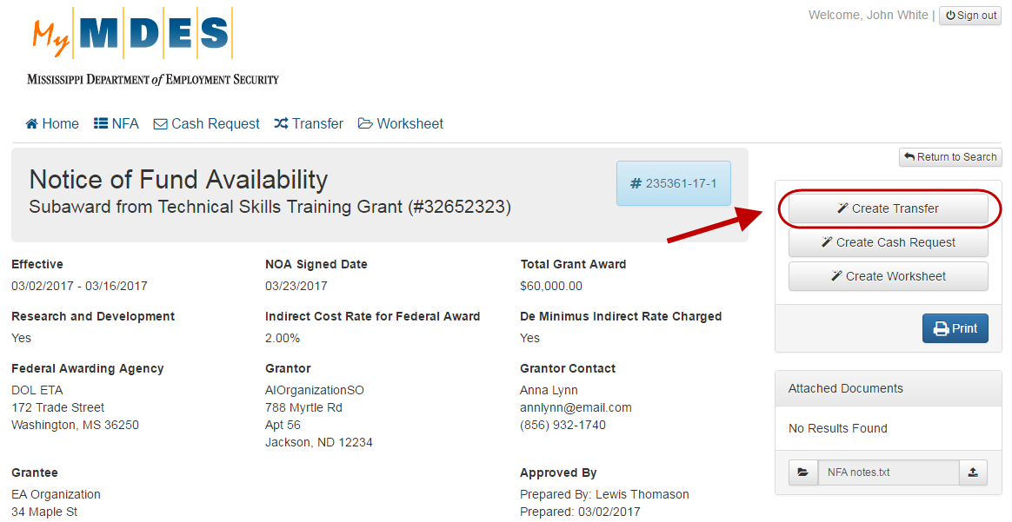
Step 3: On the New Transfer Request screen, complete the fields and click Save.
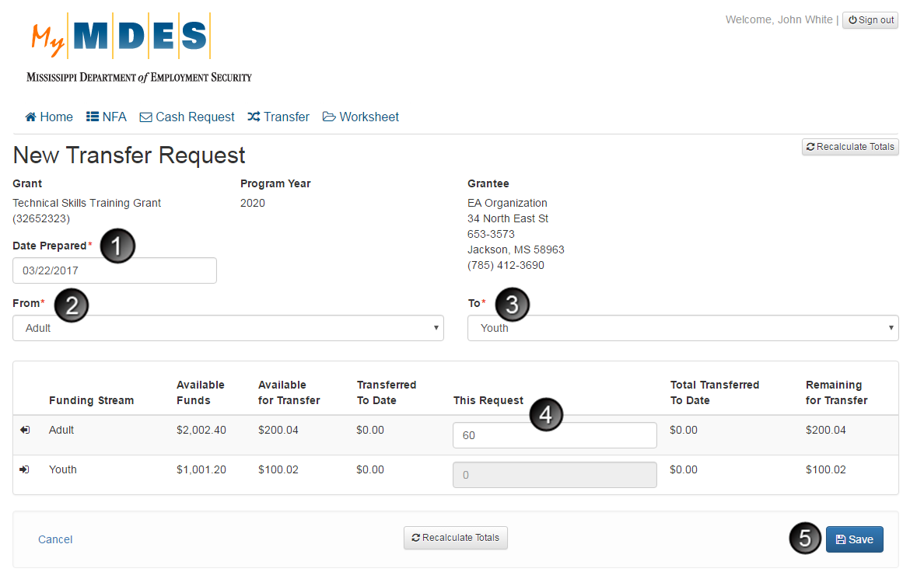
- In the Date Prepared field, select the date for the transfer request.
- Select the transfer source in the From field.
- Select the transfer destination in the To field.
- In the This Request column, enter the planned transfer amount.
- Click Save to create the transfer.

NOTES:
- Completing the From/To fields will display the corresponding funding stream details.
- Use the Recalculate Totals button to recalculate the remaining amount according to the entered request value.

Searching for a Transfer
Grantee Staff members, Grantee Managers, Grantee Directors, Grantee Executives, and Board Chairmen can search for transfers.
Step 1: Click Transfer.
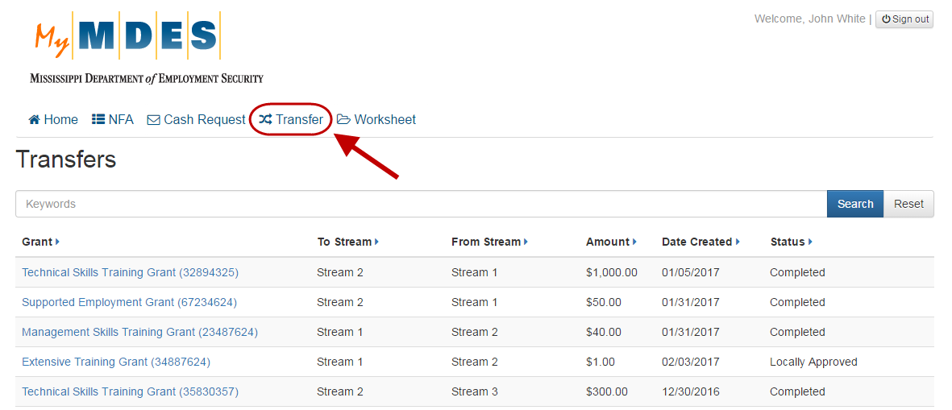
Step 2: Type a Transfer keyword and click Search.
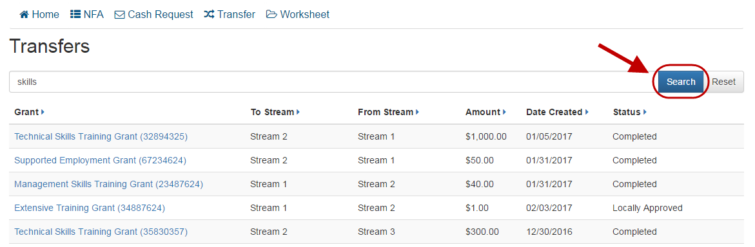
Search Results Screen
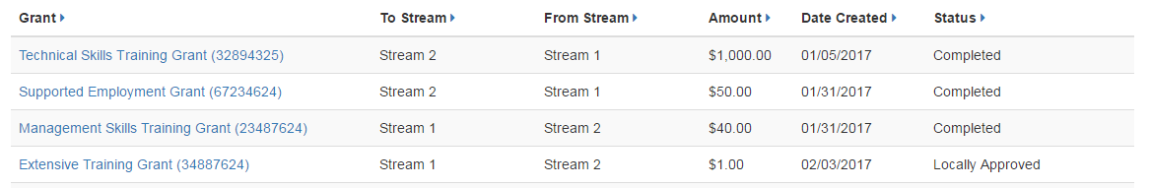
Clicking any grant name in the search results will open the corresponding Transfer View screen. For more details, refer to the Viewing a Transfer section.

Viewing a Transfer
Grantee Staff members, Grantee Managers, Grantee Directors, Grantee Executives, and Board Chairmen can view transfers.
To open a Transfer View screen with associated details, click the grant name in the search results list. For details on how to search for a transfer, refer to the Searching for a Transfer section.
Transfer View Screen
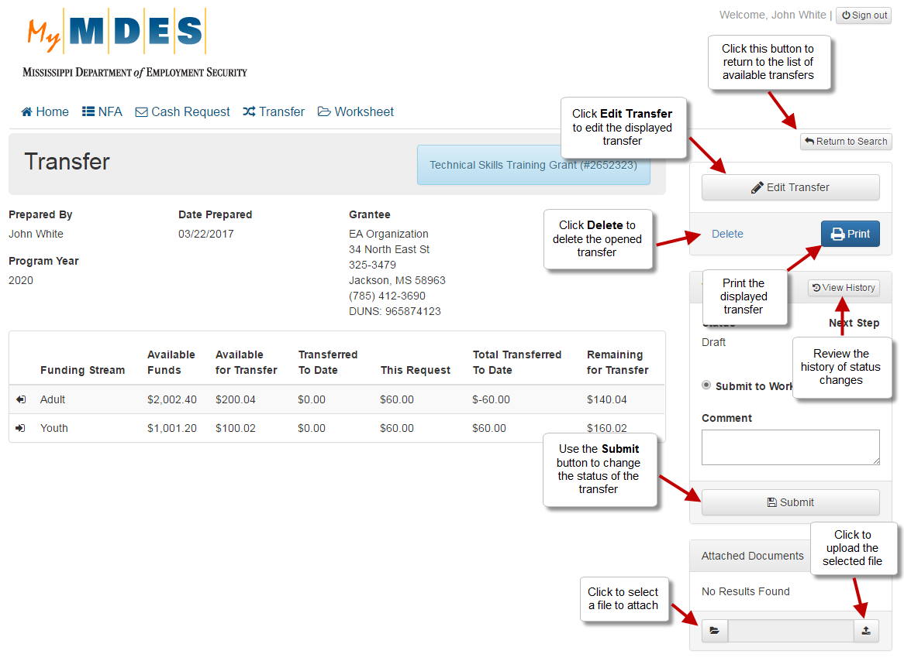
NOTE: The number of available actions on the screen depends on the status of the transfer.
Attach Documents to a Transfer

On a Transfer View screen, you can attach documents to the selected transfer. To attach a document:
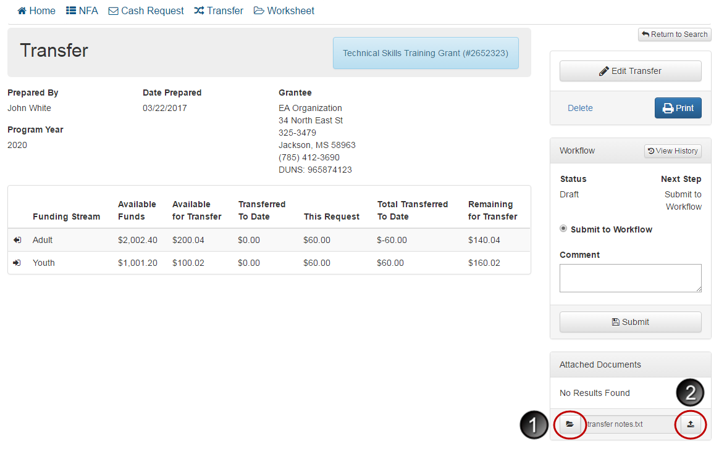
- Click the folder icon and select the required document from your local directory.
- Click the upload icon to attach the selected file.

Editing a Transfer
Grantee Staff members, Grantee Managers, Grantee Directors, and Grantee Executives can edit transfers that have a status of ‘Draft’.
Information related to a transfer can be modified from the associated Transfer View screen. For details on functions available for transfers, refer to the Viewing a Transfer section.
Step 1: Click the Edit Transfer button on the Transfer View screen.
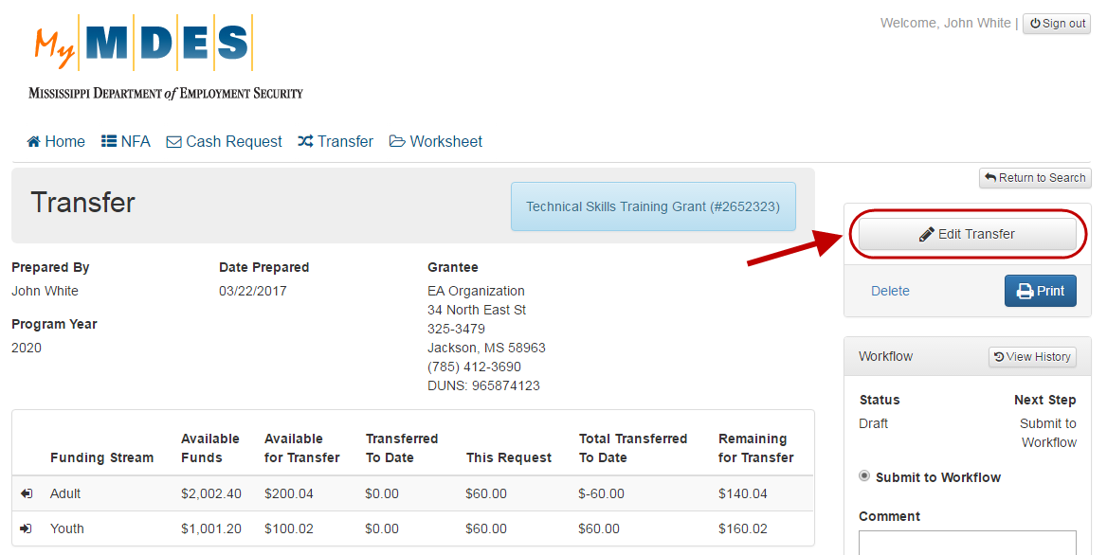
Step 2: Edit information as necessary and click Save.
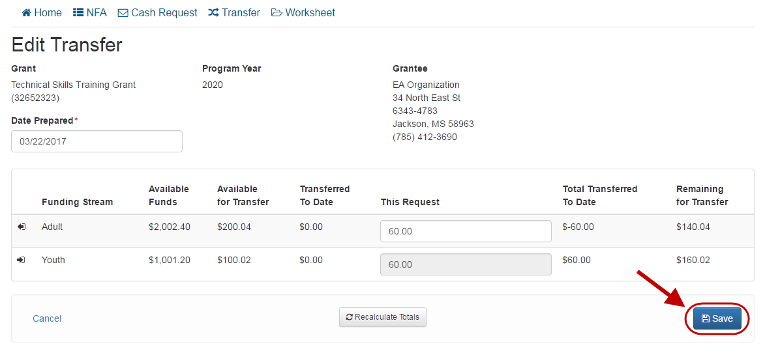
NOTE: Use the Recalculate Totals button to recalculate the remaining amount according to the entered request value.

Deleting a Transfer
Grantee Staff members, Grantee Managers, Grantee Directors, and Grantee Executives can delete transfers that have a status of ‘Draft’.
Information related to a transfer can be removed from the associated Transfer View screen. For details on functions available for transfers, refer to the Viewing a Transfer section.
Step 1: Click the Delete link on the Transfer View screen.
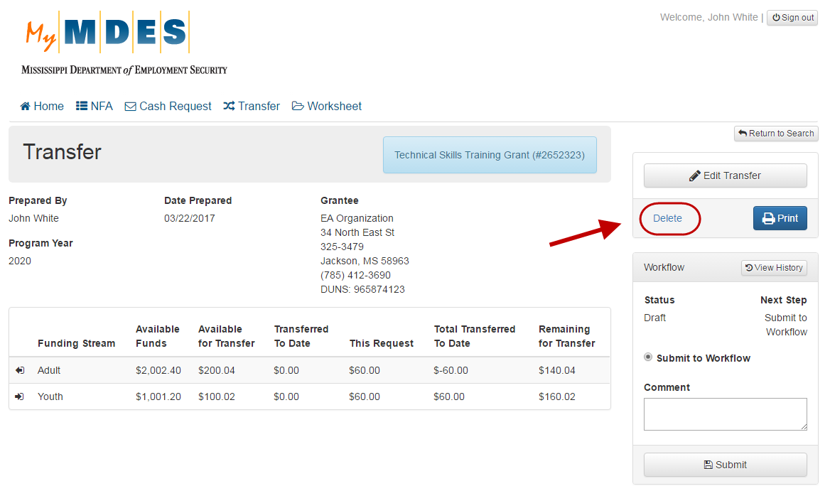
Step 2: Click Yes to confirm the removal.
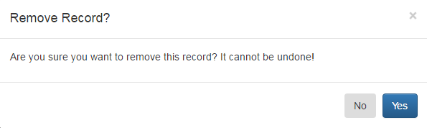

Submitting a Transfer to Workflow
Grantee Staff members, Grantee Managers, Grantee Directors and Grantee Executives can submit transfers to Workflow.
In order to initiate the process of approving a transfer, it must be submitted to Workflow from the associated Transfer View screen. For details on other actions available for transfers, refer to the Viewing a Transfer section.
Submit a Transfer to Workflow
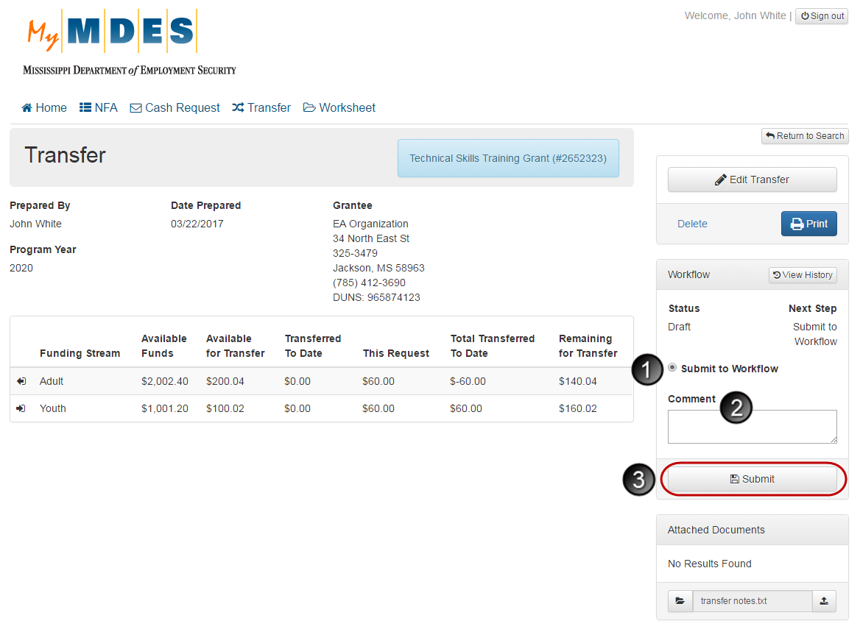
To submit a transfer to Workflow:
- Select Submit to Workflow in the Workflow section.
- Enter a comment in the Comment field.
- Click the Submit button.
NOTE: Clicking Submit will change the status from ‘Draft to ‘Submitted to Workflow’.

Signing a Transfer
Grantee Managers, Grantee Directors, Grantee Executives and Board Chairmen can locally sign transfers that have a status of ‘Submitted to Workflow’.
Transfers can be signed from the associated Transfer View screen. For details on other actions available for transfers, refer to the Viewing a Transfer section.
Sign a Transfer
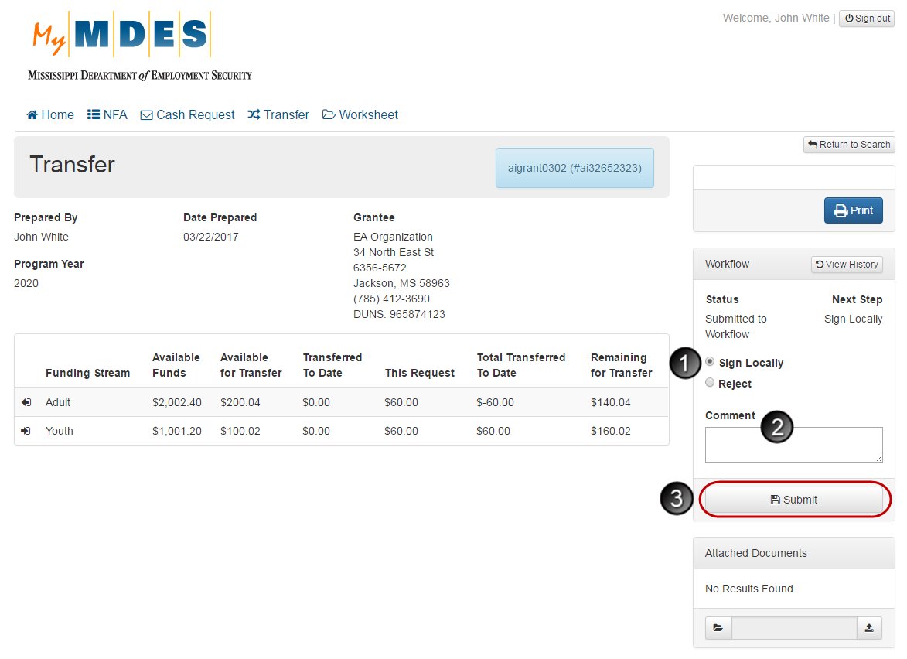
To sign a Transfer:
- Select Sign Locally in the Workflow section.
- Enter a comment in the Comment field.
- Click the Submit button.
NOTE: Clicking Submit will change the status to ‘Locally Signed’.
Once the transfer has been locally signed, further status changes (state review, approval and sign off) are available only to State Office users.

Rejecting Status Changes
If necessary, a status change, which has been submitted, can be rejected.
NOTE: After a transfer has been locally signed, the status cannot be rejected.
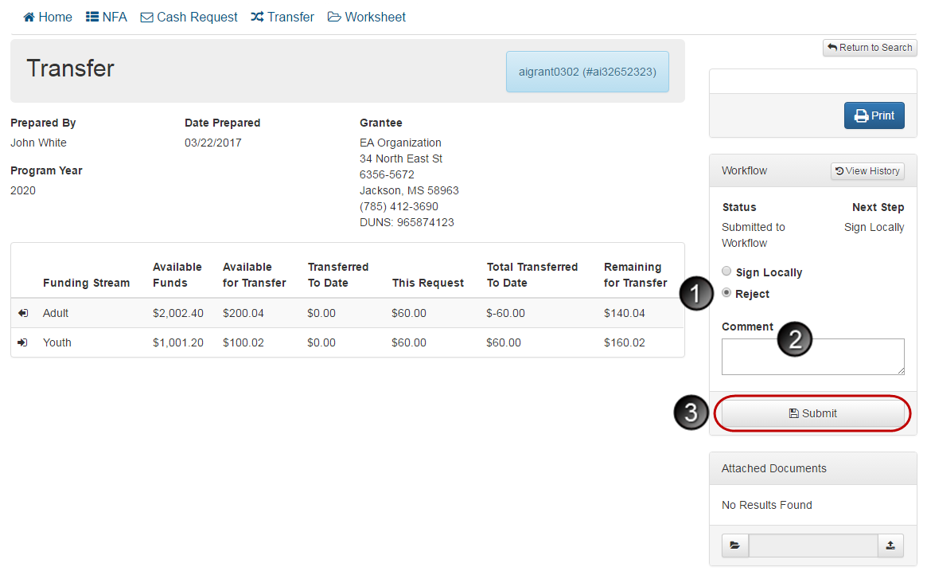
To reject a status change:
- Select Reject in the Workflow section.
- Enter a comment in the Comment field.
- Click the Submit button.
NOTE: Clicking Submit will change the status to ‘Draft’.

Worksheet

Creating a Worksheet
GrantTrak allows Grantee Staff members, Grantee Managers, Grantee Directors and Grantee Executives create worksheets.
Worksheets are created from the Notice of Fund Availability View screen. For details on other actions available for an NFA, refer to the Viewing a Notice of Fund Availability section.
Step 1: Click NFA and select the required NFA, from which you want to create a worksheet.
Step 2: On the Notice of Fund Availability View screen, click Create Worksheet.
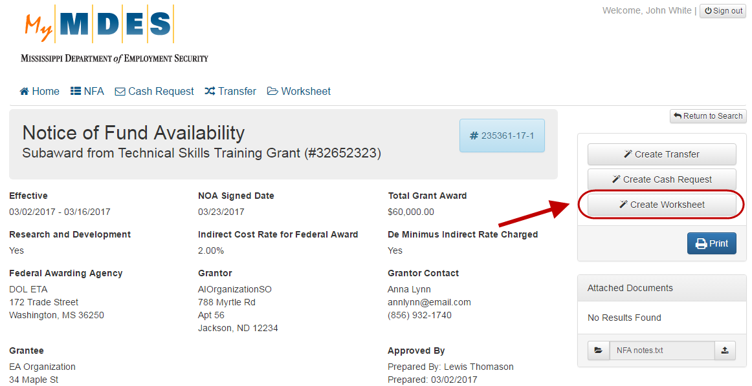

Step 3: Complete the fields on the New Worksheet screen and click Save.
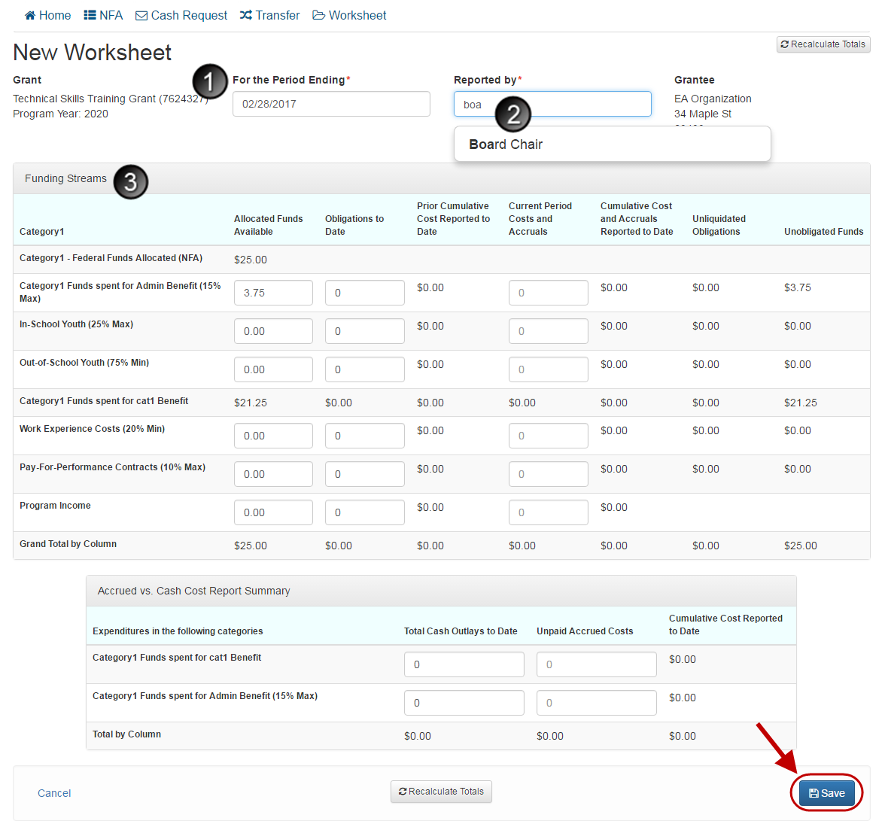
- Select the appropriate date in the For the Period Ending field.
- Enter at least 3 first characters of the username that requested the worksheet in the Reported by field and select the necessary option in the dropdown list.
- If funding streams and allocations were provided, enter values in the corresponding fields as necessary.

Searching for a Worksheet
Grantee Staff members, Grantee Managers, Grantee Directors, and Grantee Executives can search for worksheets.
Step 1: Click Worksheet in the top menu.
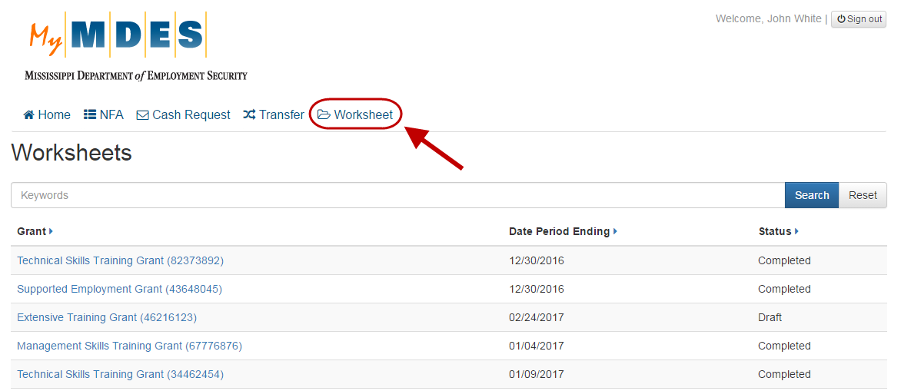
Step 2: Search for a worksheet by type a keyword and clicking Search.
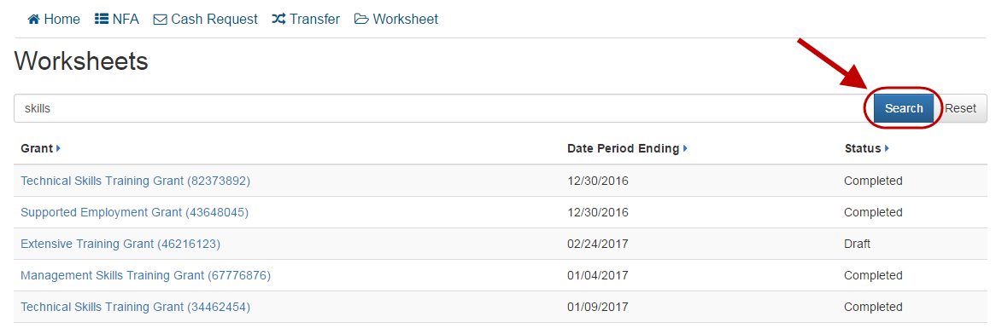
Search Results Screen
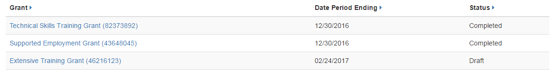
Clicking any grant name in the search results will open the corresponding Worksheet View screen. For more details, refer to the Viewing a Worksheet section.

Viewing a Worksheet
Grantee Staff members, Grantee Managers, Grantee Directors, and Grantee Executives can view worksheets.
To open a Worksheet View screen with associated details, click the grant name in the search results list. For details on how to search for a worksheet, refer to the Searching for a Worksheet section.
Worksheet View Screen (the number of available options on the screen may differ depending on your role in the system)
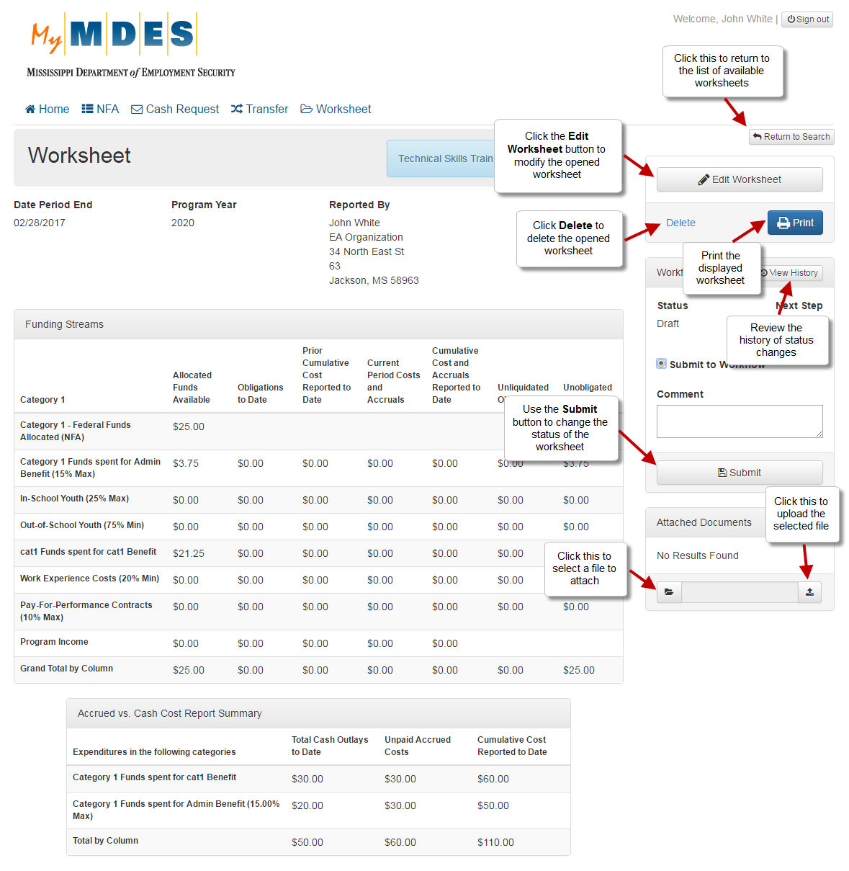
NOTE: The number of available actions on the screen depends on the status of the worksheet.
Attach Documents to a Worksheet

On a Worksheet View screen, you can attach documents to the displayed worksheet. To attach a document:
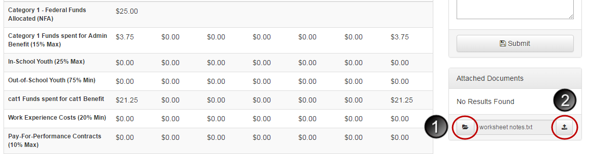
- Click the folder icon and select the required document from your local directory.
- Click the upload icon to attach the selected file.

Editing a Worksheet
Grantee Staff members, Grantee Managers, Grantee Directors and Grantee Executives can edit worksheets that have a status of ‘Draft’.
Information related to a worksheet can be modified from the associated Worksheet View screen. For details on actions available from a Worksheet View screen, refer to the Viewing a Worksheet section.
Step 1: Click the Edit Worksheet button on the Worksheet View screen.
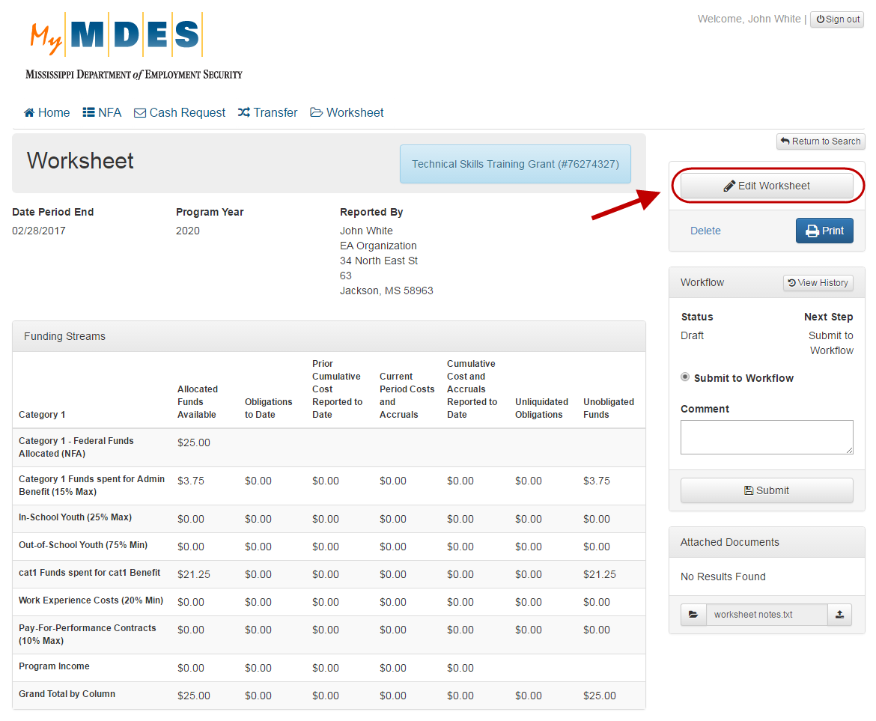
Step 2: Edit information as necessary and click Save.
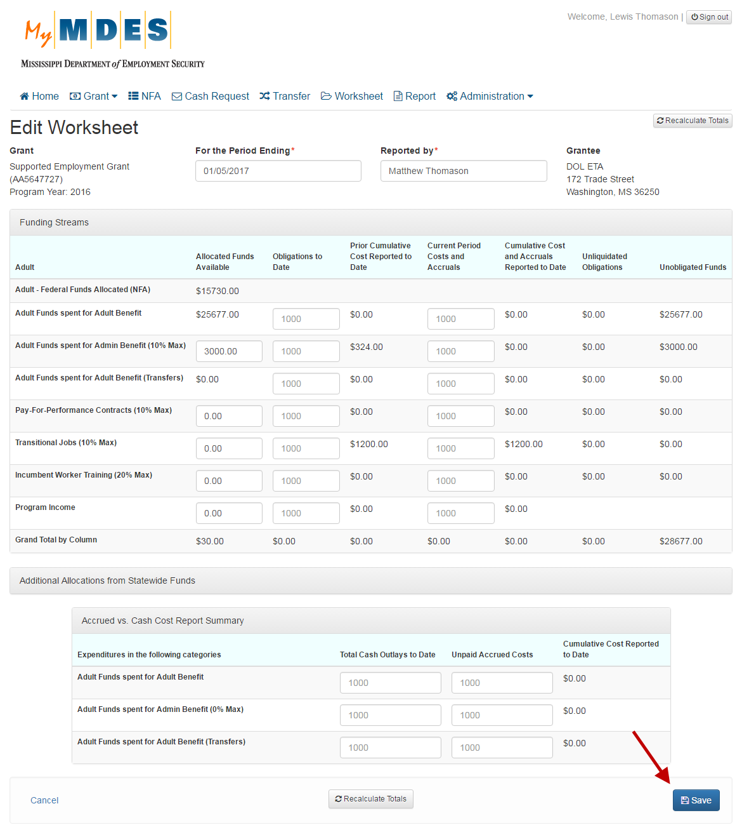

Deleting a Worksheet
Grantee Staff members, Grantee Managers, Grantee Directors and Grantee Executives can delete worksheets that have a status of ‘Draft’.
Information related to a worksheet can be deleted from the associated Worksheet View screen. For details on actions available from a Worksheet View screen, refer to the Viewing a Worksheet section.
Step 1: Click the Delete link on the Worksheet View screen.
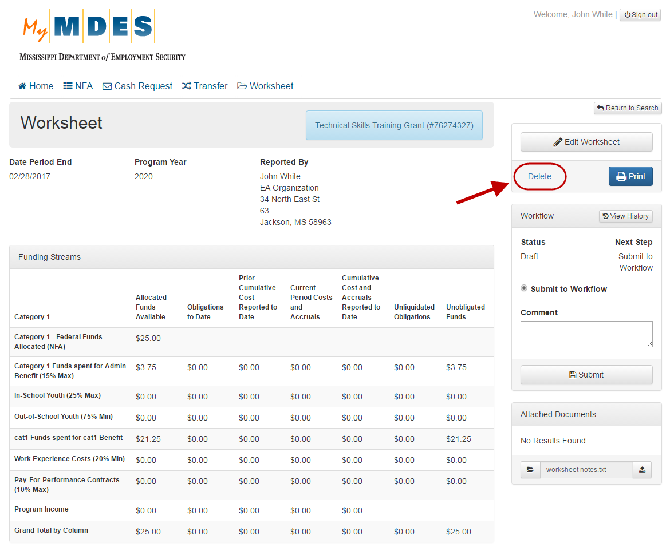
Step 2: Click Yes to confirm the removal.
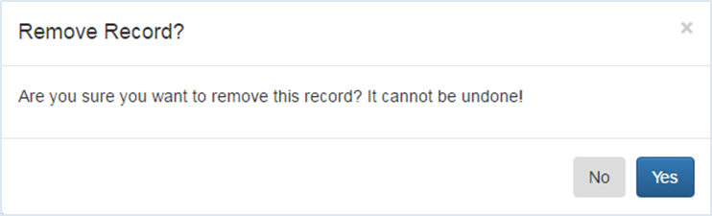

Submitting a Worksheet to Workflow
Grantee Managers, Grantee Directors and Grantee Executives can submit worksheets to Workflow.
In order to initiate the process of approving a worksheet, it must be submitted to Workflow from the associated Worksheet View screen. For details on actions available for worksheets, refer to the Viewing a Worksheet section.
Submit a Worksheet to Workflow
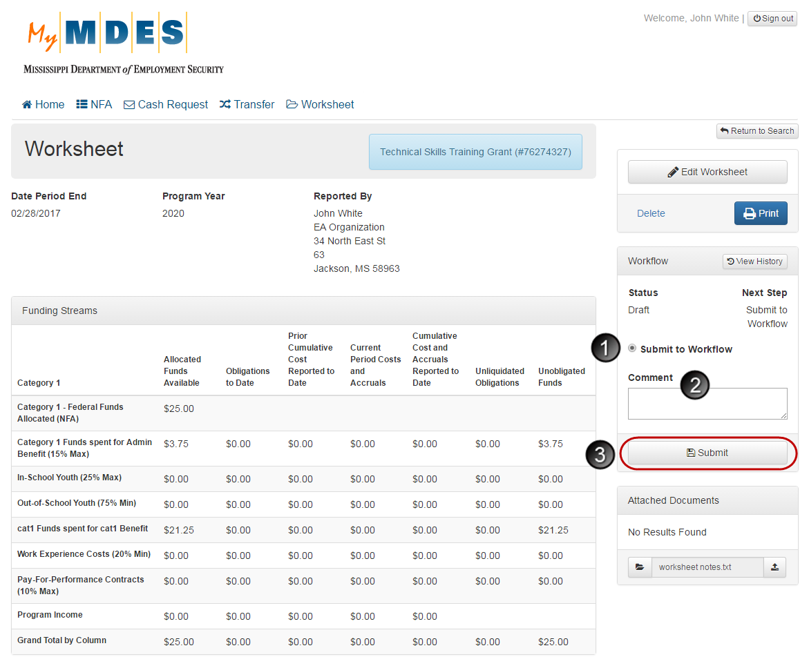
To submit a worksheet to Workflow:
- Select Submit to Workflow in the Workflow section.
- Enter a comment in the Comment field.
- Click the Submit button.
NOTE: Clicking Submit will change the status from ‘Draft to ‘Submitted to Workflow’.

Signing a Worksheet
Grantee Managers, Grantee Directors, Grantee Executives can locally sign worksheets that have a status of ‘Submitted to Workflow’.
Worksheets can be signed from the associated Worksheet View screen. For details on other actions available for worksheets, refer to the Viewing a Worksheet section.
Sign a Worksheet
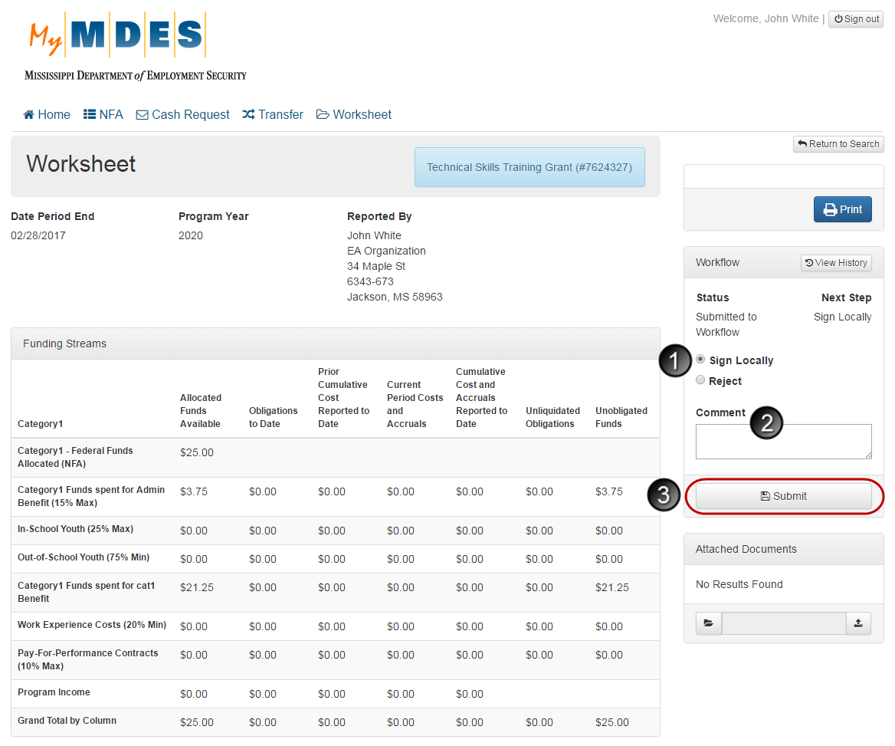
To sign a worksheet:
- Select Sign Locally in the Workflow section.
- Enter a comment in the Comment field.
- Click the Submit button.
NOTE: Clicking Submit will change the status to ‘Locally Signed’ or ‘Completed’.
Once the worksheet has been locally signed, further status changes (state review, approval and sign off) are available only to State Office users.

Rejecting Status Changes
If necessary, a status change, which has been submitted, can be rejected.
NOTE: After a worksheet has been locally signed, the status cannot be rejected.
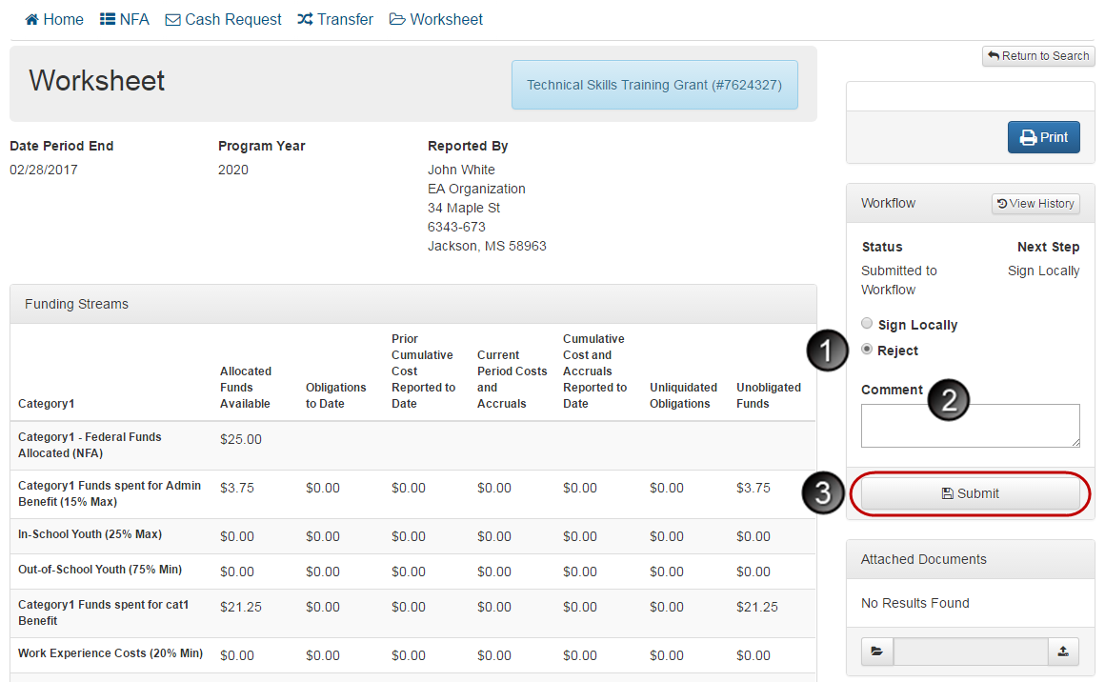
To reject a status change:
- Select Reject in the Workflow section.
- Enter a comment in the Comment field.
- Click the Submit button.
NOTE: Clicking Submit will change the status to ‘Draft’.

